1). Настроим роутер 1:

-настроим поочередно каждый интерфейс:

Fastethernet 0/0

Router>enable

Router#conf t

Enter configuration commands, one per line. End with CNTL/Z.

Router(config)#inter

Router(config)#interface fa 0/0

Router(config-if)#ip addr

Router(config-if)#ip address 192.168.10.1 255.255.255.252

Router(config-if)#no shu

Router(config-if)#no shutdown

Router(config-if)#exit

Fastethernet 0/1

Router(config)#inter

Router(config)#interface fa 0/1

Router(config-if)#ip addr

Router(config-if)#ip address 10.19.1.1 255.255.255.0

Router(config-if)#no shu

Router(config-if)#no shutdown

Router(config-if)#exit

Fastetherner 1/0

Router(config)#inter

Router(config)#interface fa 0/0

Router(config-if)#ip addr

Router(config-if)#ip address 192.168.1.1 255.255.255.0

Router(config-if)#no shu

Router(config-if)#no shutdown

Router(config-if)#exit

Сохраняем:

Router#write memory

Building configuration...

[OK]

Настроим роутер 2:

-настроим поочередно каждый интерфейс:

Fastethernet 0/0

Router>enable

Router#conf t

Enter configuration commands, one per line. End with CNTL/Z.

Router(config)#inter

Router(config)#interface fa 0/0

Router(config-if)#ip addr

Router(config-if)#ip address 192.168.10.2 255.255.255.252

Router(config-if)#no shu

Router(config-if)#no shutdown

Router(config-if)#exit

Fastethernet 0/1

Router(config)#inter

Router(config)#interface fa 0/1

Router(config-if)#ip addr

Router(config-if)#ip address 192.168.10.6 255.255.255.252

Router(config-if)#no shu

Router(config-if)#no shutdown

Router(config-if)#exit

Fastetherner 1/0

Router(config)#inter

Router(config)#interface fa 0/0

Router(config-if)#ip addr

Router(config-if)#ip address 192.168.2.1 255.255.255.0

Router(config-if)#no shu

Router(config-if)#no shutdown

Router(config-if)#exit

Сохраняем:

Router#write memory

Building configuration...

[OK]

Настроим роутер 3:

-настроим поочередно каждый интерфейс:

Fastethernet 0/0

Router>enable

Router#conf t

Enter configuration commands, one per line. End with CNTL/Z.

Router(config)#inter

Router(config)#interface fa 0/0

Router(config-if)#ip addr

Router(config-if)#ip address 10.19.1.2 255.255.255.0

Router(config-if)#no shu

Router(config-if)#no shutdown

Router(config-if)#exit

Fastethernet 0/1

Router(config)#inter

Router(config)#interface fa 0/1

Router(config-if)#ip addr

Router(config-if)#ip address 192.168.10.5 255.255.255.252

Router(config-if)#no shu

Router(config-if)#no shutdown

Router(config-if)#exit

Fastetherner 1/0

Router(config)#inter

Router(config)#interface fa 0/0

Router(config-if)#ip addr

Router(config-if)#ip address 192.168.3.1 255.255.255.0

Router(config-if)#no shu

Router(config-if)#no shutdown

Router(config-if)#exit

Сохраняем:

Router#write memory

Building configuration...

[OK]

Назначим ip-адреса компьютерам и серверам, так как n - не четное, то для PC0 и PC1 за default gateaway выберем Router3:

IP for PC1: 10.19.1.29 /24

Default gateaway: 10.19.1.3

IP for PC1: 10.19.1.30 /24

Default gateaway: 10.19.1.3

2). Настроим RIP:

Router 1:

Router>enable

Router#conf t

Enter configuration commands, one per line. End with CNTL/Z.

Router(config)#rout

Router(config)#router rip

Router(config-router)#ver

Router(config-router)#version 2

Router(config-router)#net

Router(config-router)#network 192.168.1.0

Router(config-router)#network 192.168.10.0

Router(config-router)#network 10.19.1.0

Router(config-router)#end

Router#write memory

Building configuration...

[OK]

Router 2:

Router>enable

Router#conf t

Enter configuration commands, one per line. End with CNTL/Z.

Router(config)#rout

Router(config)#router rip

Router(config-router)#ver

Router(config-router)#version 2

Router(config-router)#net

Router(config-router)#network 192.168.2.0

Router(config-router)#network 192.168.10.4

Router(config-router)#network 192.168.10.0

Router(config-router)#end

Router#write memory

Building configuration...

[OK]

Router 3:

Router>enable

Router#conf t

Enter configuration commands, one per line. End with CNTL/Z.

Router(config)#rout

Router(config)#router rip

Router(config-router)#ver

Router(config-router)#version 2

Router(config-router)#net

Router(config-router)#network 10.19.1.0

Router(config-router)#network 192.168.3.0

Router(config-router)#network 192.168.10.4

Router(config-router)#end

Router#write memory

Building configuration...

[OK]

3). Итого, для каждых маршрутизаторов значения команд show ip route, show ip interface brief и show ip rip database:

Router 1: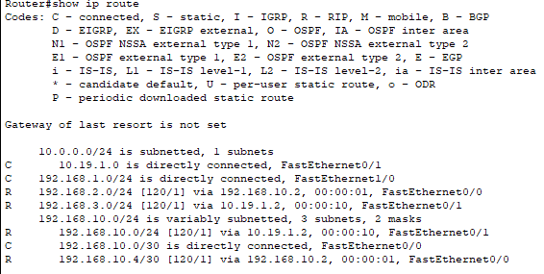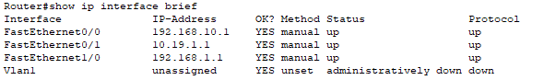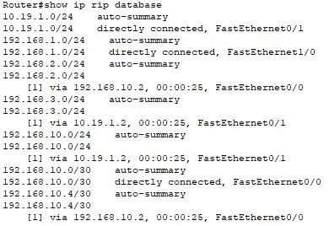

Router 2:

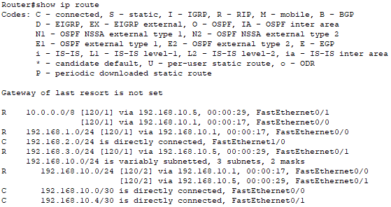

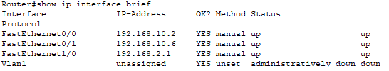

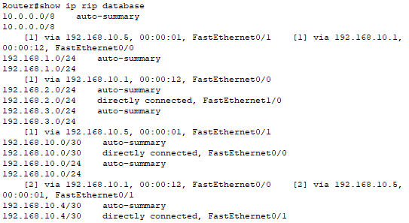

Router 3:

